

GILDART HAASE SCHOOL OF COMPUTER SCIENCES AND ENGINEERING

University College: Arts – Sciences – Professional Studies

Fairleigh Dickinson University

__________________________________________________________

*Student’s Name: Professor:*

Desham,RajeshReddy (1682826) *Alex Rudniy,Ph.D* **LastName, First Name(Student I.D)**

**CSCI 6885_81**

**Big Data Analytics with Hadoop and R**

**SPRING 2016**

Assignment-5

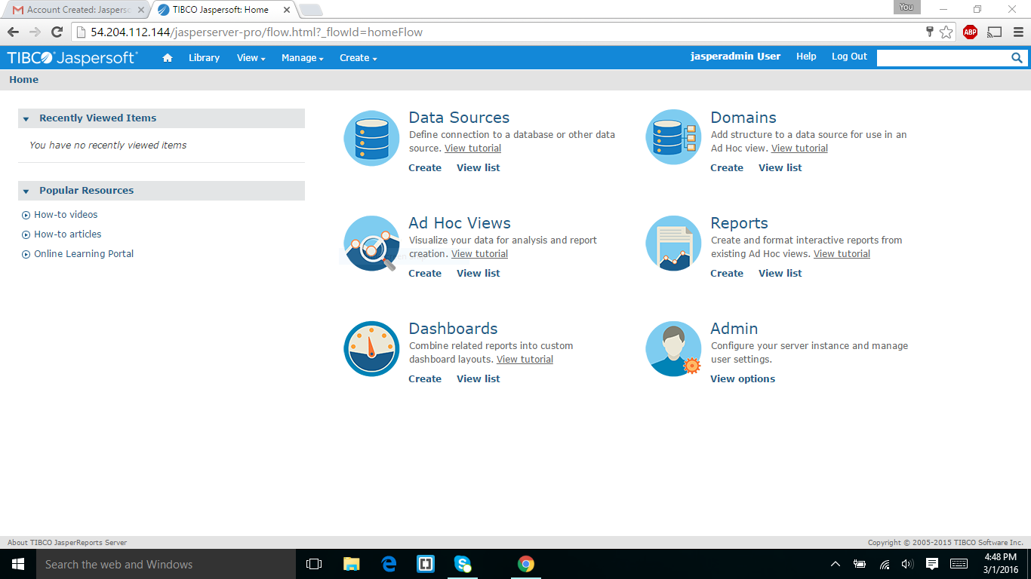

I have login to jaspersoft and it shows data sources,domains ,ad hoc views,reports,and dashboard and admin.

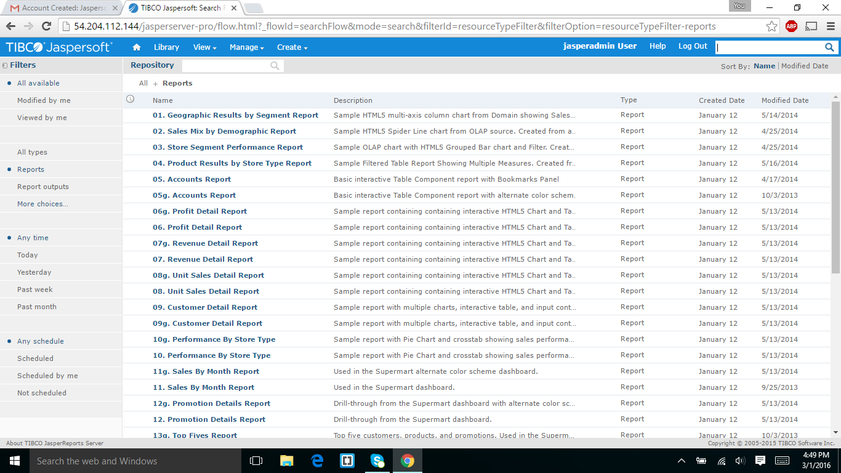

The above screen shot show the view list which display the reports.

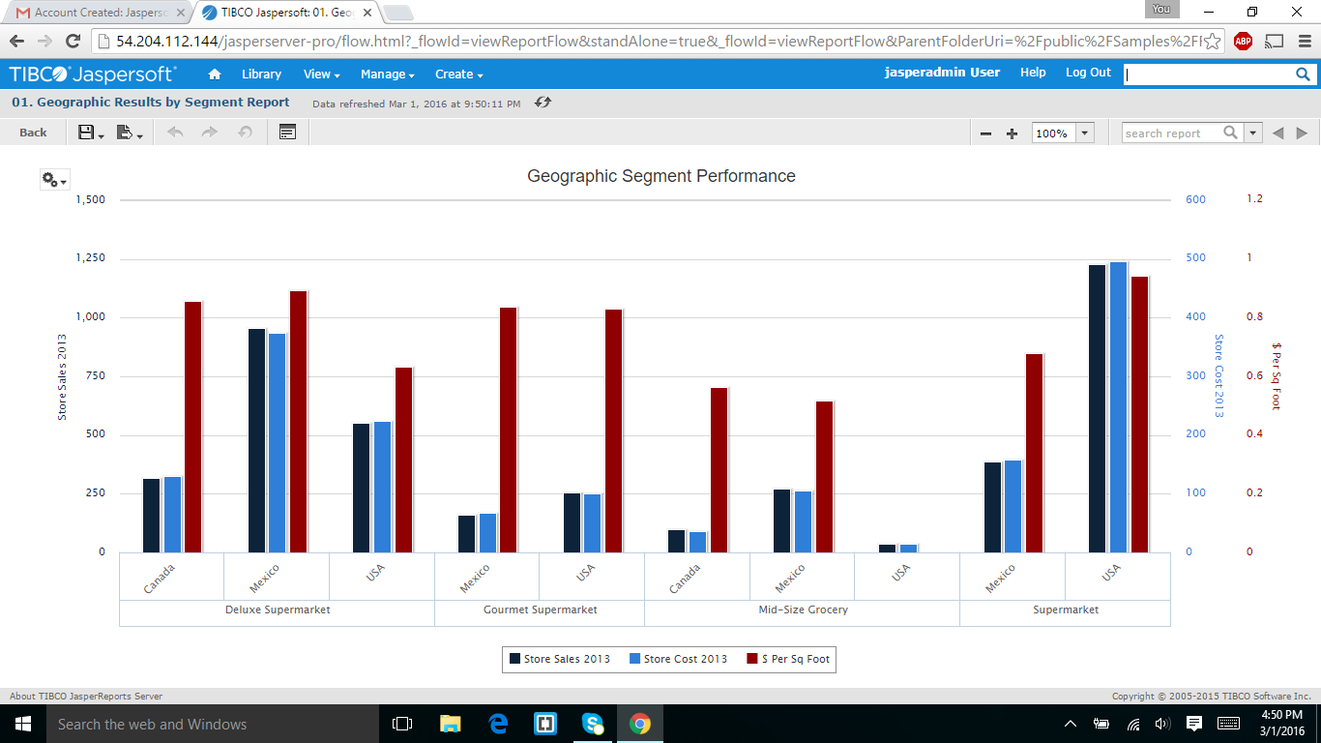

The above screen shot shows about the geographic Results by segment report.

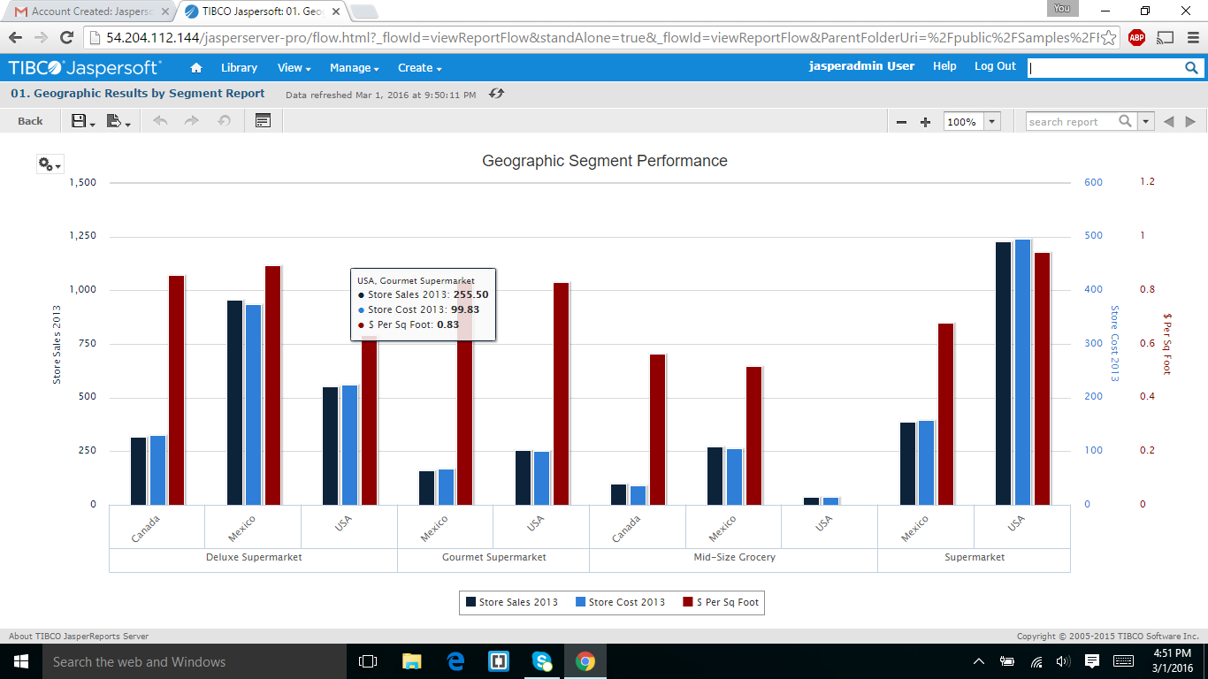

The above screen shot displayed about the geographic results by segment when I moved the cursor on different places it showssome results in popup window.

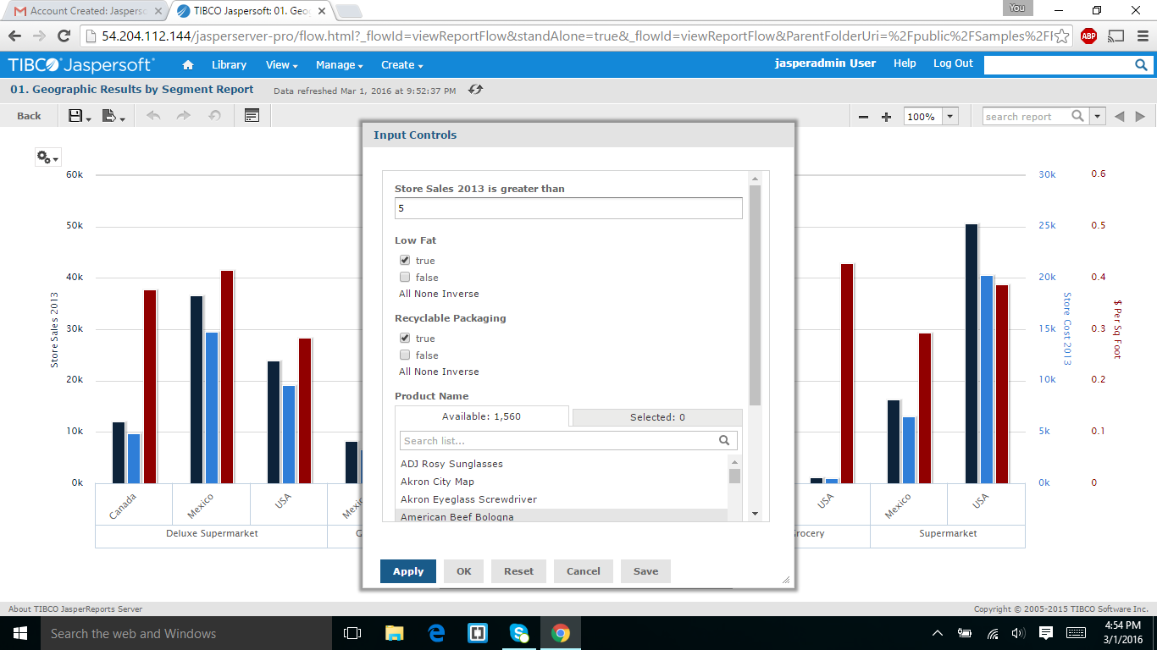

In the above screen shot I set the required values shown in the assignment and the results were displayed in the next slide.

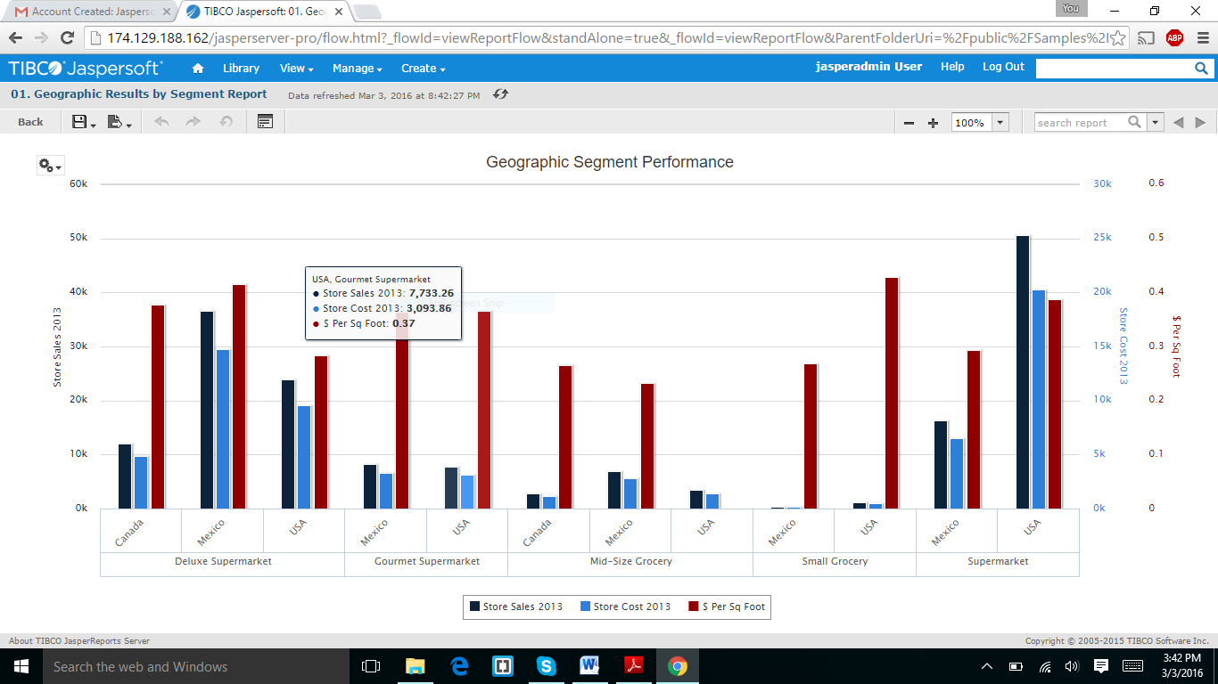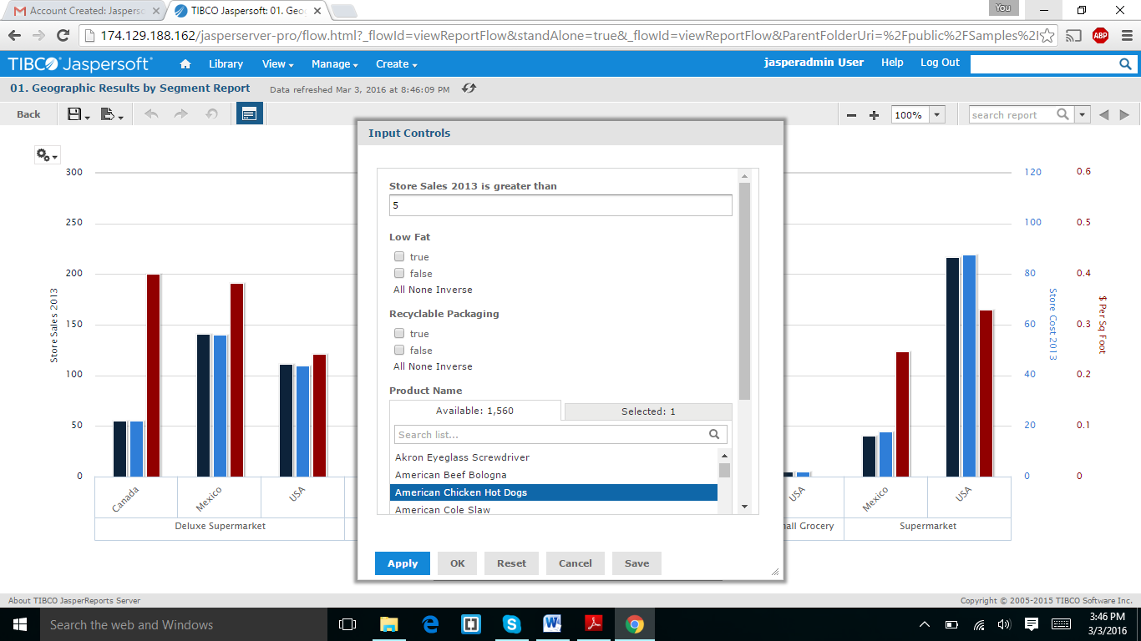

In the above screen I set the value for American chicken hotdogs and it displayed the results as below screen shot.

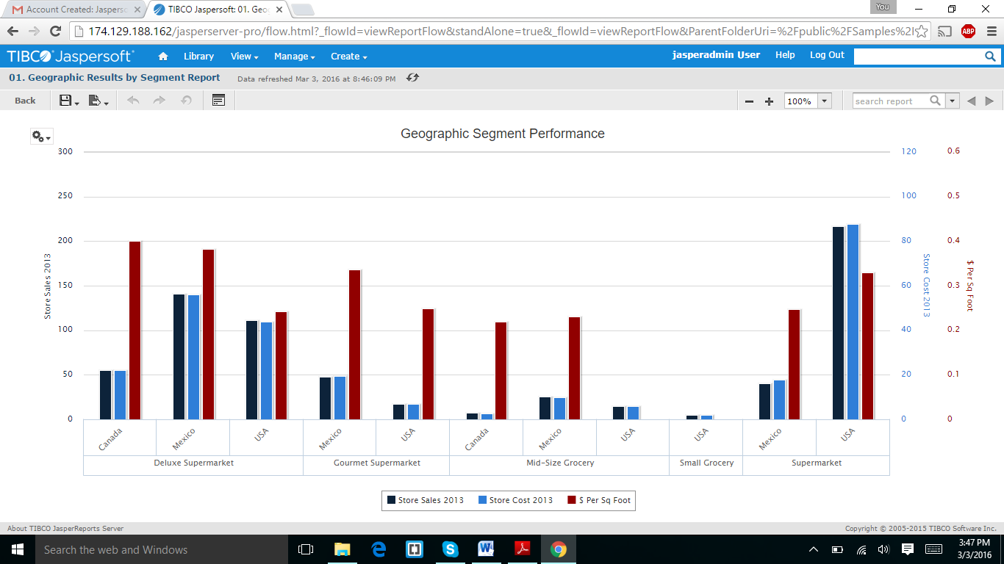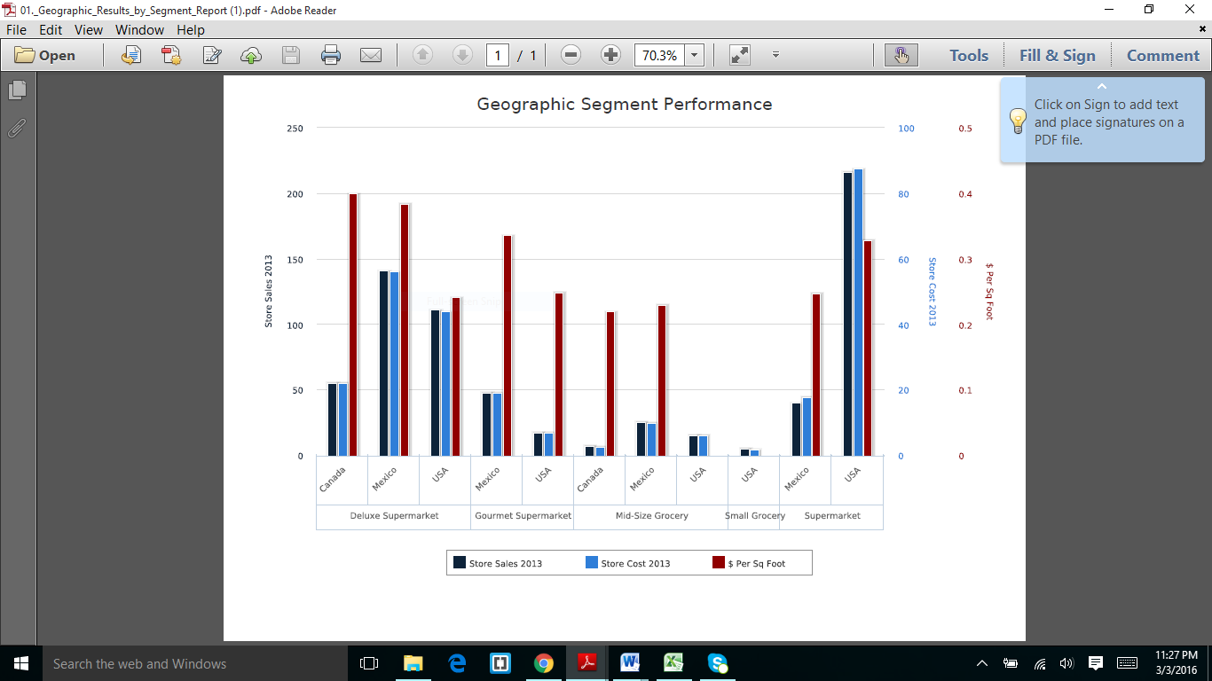

I export the report as pdf.

PART2:

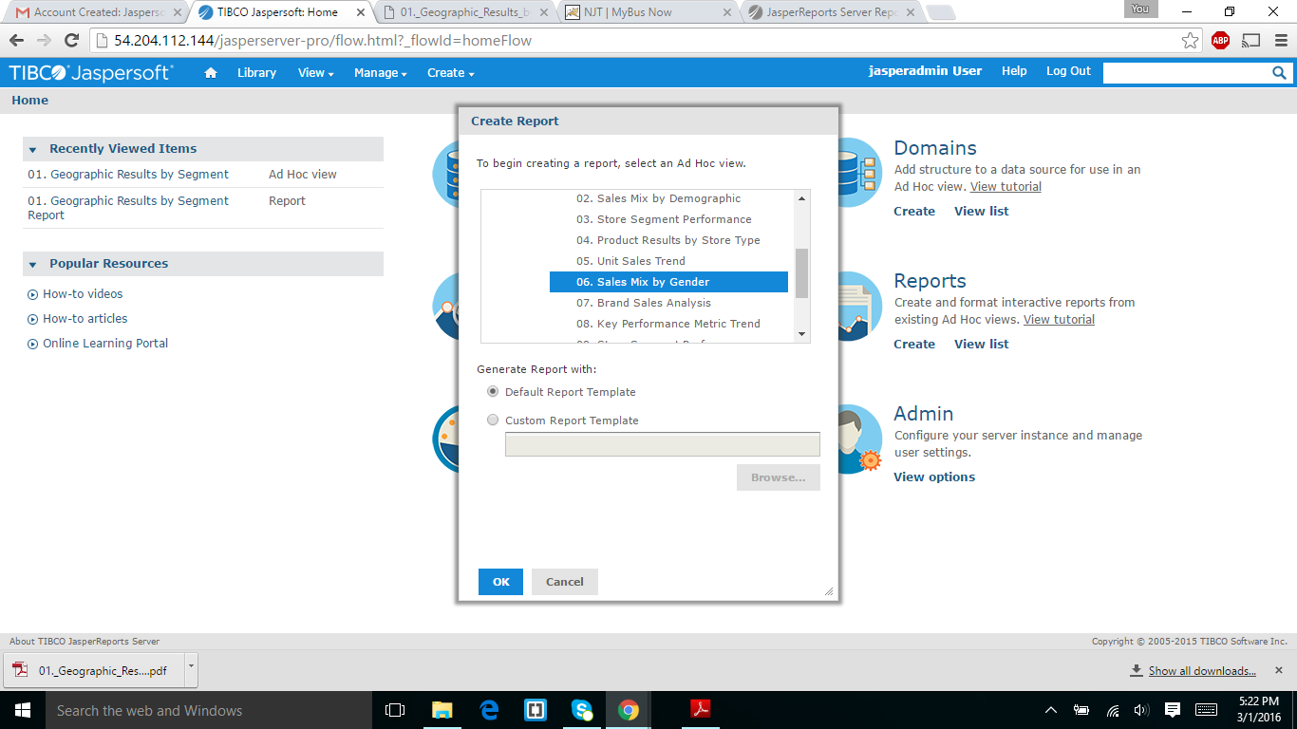

I selected the 06 sales mix by gender as which you that in student id.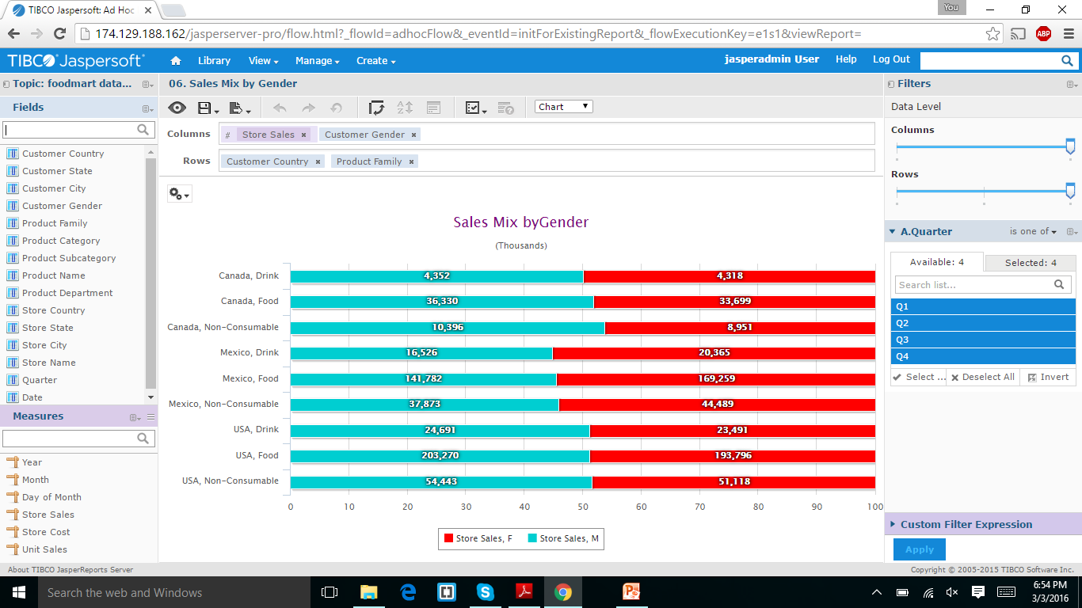

It was displayed the above result which it and I export it into excel file,by pressing the export button.

.

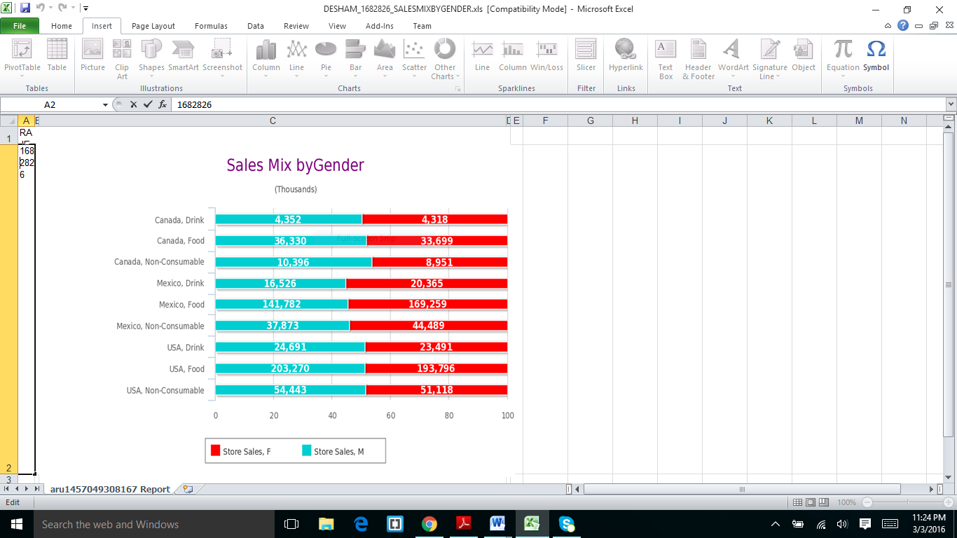

I captured and I rename the file name with my id and name.